Design Patterns

Template Method Pattern

Location:

ganttproject\ganttproject\src\main\java\net\sourceforge\ganttproject\importer\ImporterBase.java

Explanation: Defines a general implementation for import related features, deferring the implementation of more specific steps to subclasses.

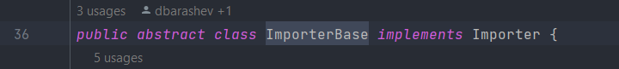

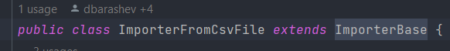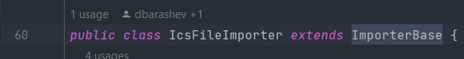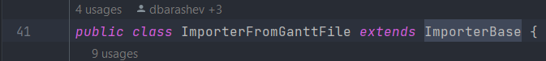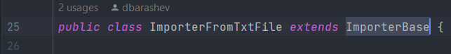

Singleton

Location:

ganttproject\biz.ganttproject.core\src\main\java\biz\ganttproject\core\chart\canvas\Canvas.java

Explanation:

The Singleton myStyles can only be accessed through its instance operation. The constructor is private and the public methods instatiate the singleton if it still doesn’t exist.

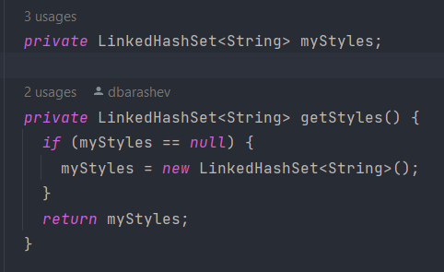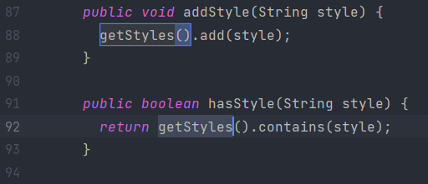

Iterator Pattern

Location:

ganttproject\biz.ganttproject.core\src\main\java\biz\ganttproject\core\time\TimeUnitStack.java

Explanation:

The iterator is used to traverse the a collection of elements and access them without exposing the underlying representation of the data structure.

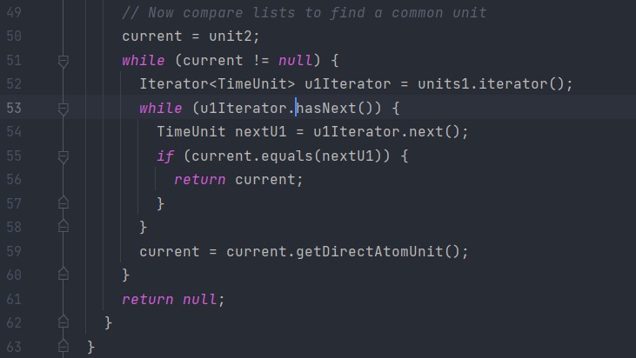

Rui Capareira, 57046